**Object class is parent of all the classes in java**

**Class and object in java**

A class in Java is a blueprint which includes all your data.  A class contain fields(variables) and methods. Let’s have a look at the syntax of a class.

class Abc {

member variables // class body

methods

}

But how can you access these member variables and methods? Here comes the concept of ***Object***.

Suppose we want to build a building, to build that building we required a blueprint or a plan[like a map created by architect].

So that blueprint is a class and that building is object

Creating an Object

As mentioned previously, a class provides the blueprints for objects. So basically, an object is created from a class. In Java, the new keyword is used to create new objects.

There are three steps when creating an object from a class −

* **Declaration** − A variable declaration with a variable name with an object type.
* **Instantiation** − The 'new' keyword is used to create the object.
* **Initialization** − The 'new' keyword is followed by a call to a constructor. This call initializes the new object.

Puppy myPuppy = new Puppy();

# Java Data Types

Data types are divided into two groups:

* Primitive data types - includes byte, short, int, long, float, double, boolean and char
* Non-primitive data types - such as [String](https://www.w3schools.com/java/java_strings.asp), [Arrays](https://www.w3schools.com/java/java_arrays.asp) and [Classes](https://www.w3schools.com/java/java_classes.asp)

|  |  |  |
| --- | --- | --- |
| **Data Type** | **Size** | **Description** |
| byte | 1 byte | Stores whole numbers from -128 to 127 |
| short | 2 bytes | Stores whole numbers from -32,768 to 32,767 |
| int | 4 bytes | Stores whole numbers from -2,147,483,648 to  2,147,483,647 |
| long | 8 bytes | Stores whole numbers from -9,223,372,036,8  54,775,808 to 9,223,372,036,854,775,807 |
| float | 4 bytes | Stores fractional numbers. Sufficient for  storing 6 to 7 decimal digits |
| double | 8 bytes | Stores fractional numbers. Sufficient for  storing 15 decimal digits |
| boolean | 1 bit | Stores true or false values |
| char | 2 bytes | Stores a single character/letter or ASCII values |

**Non-primitive data types**

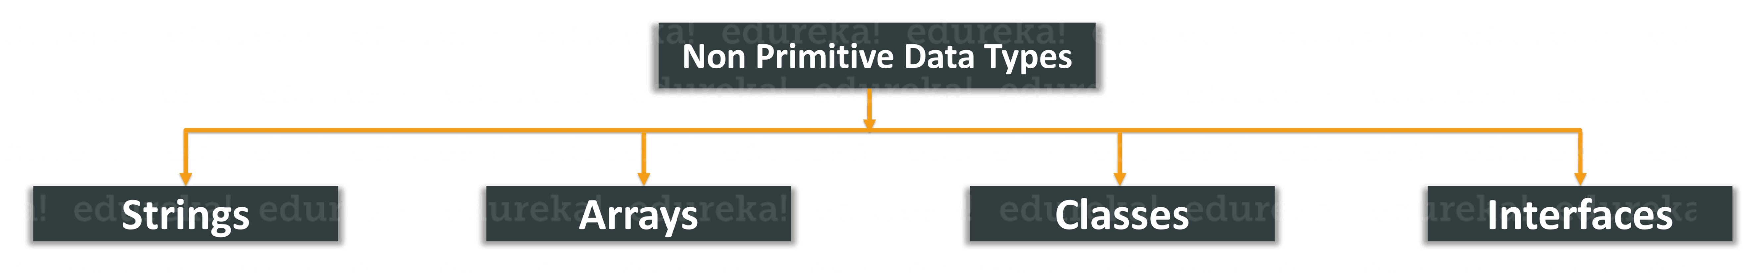

**Primitive data types vs Non-primitive data types**

* The size of a primitive type depends on the data type, while non-primitive types size can be change.

**String:**

The java.lang.String class implements Serializable, Comparable and CharSequence [interfaces](https://www.javatpoint.com/interface-in-java).

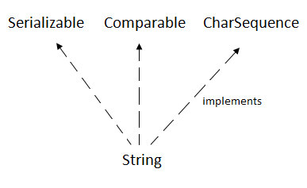

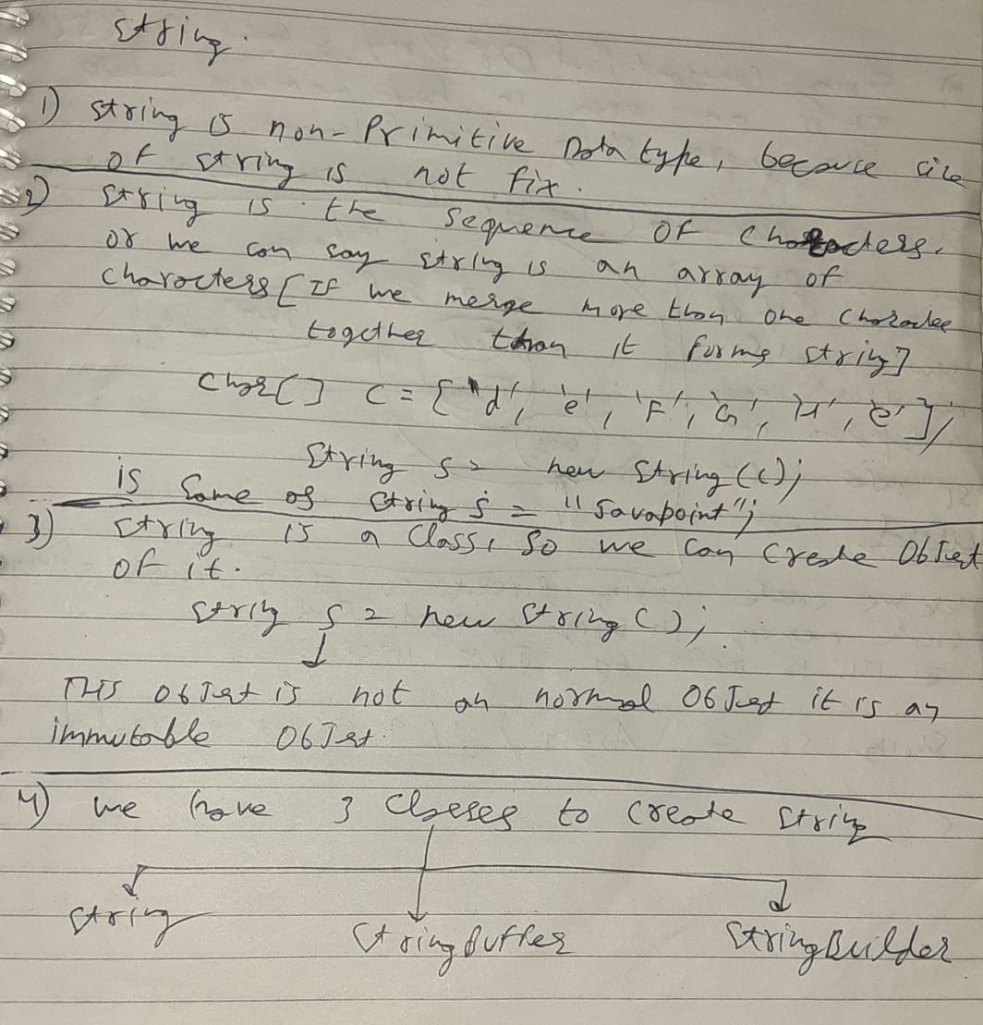

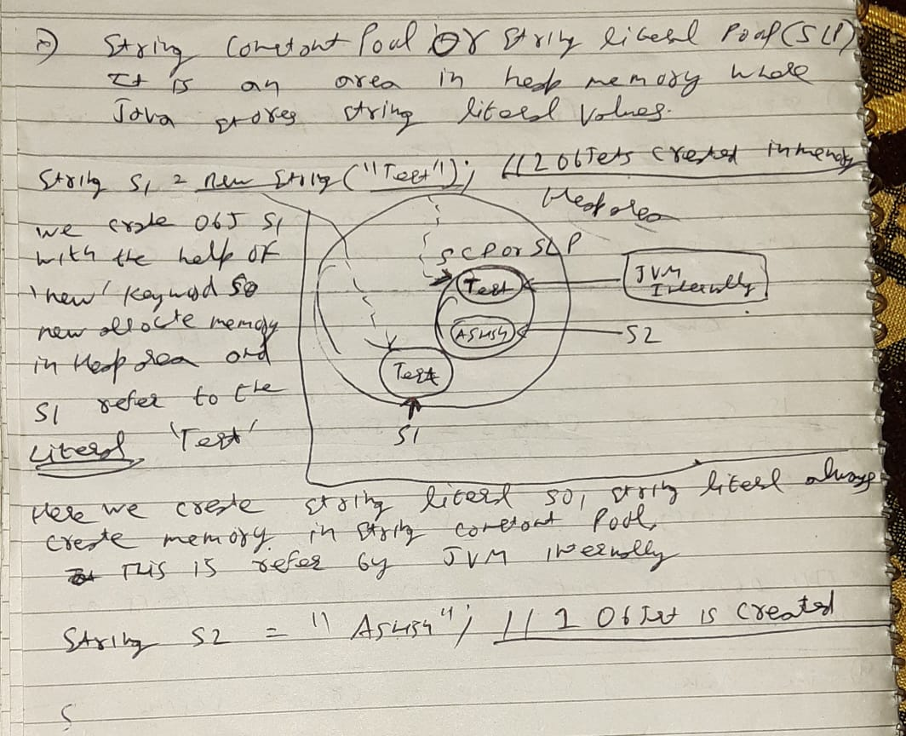

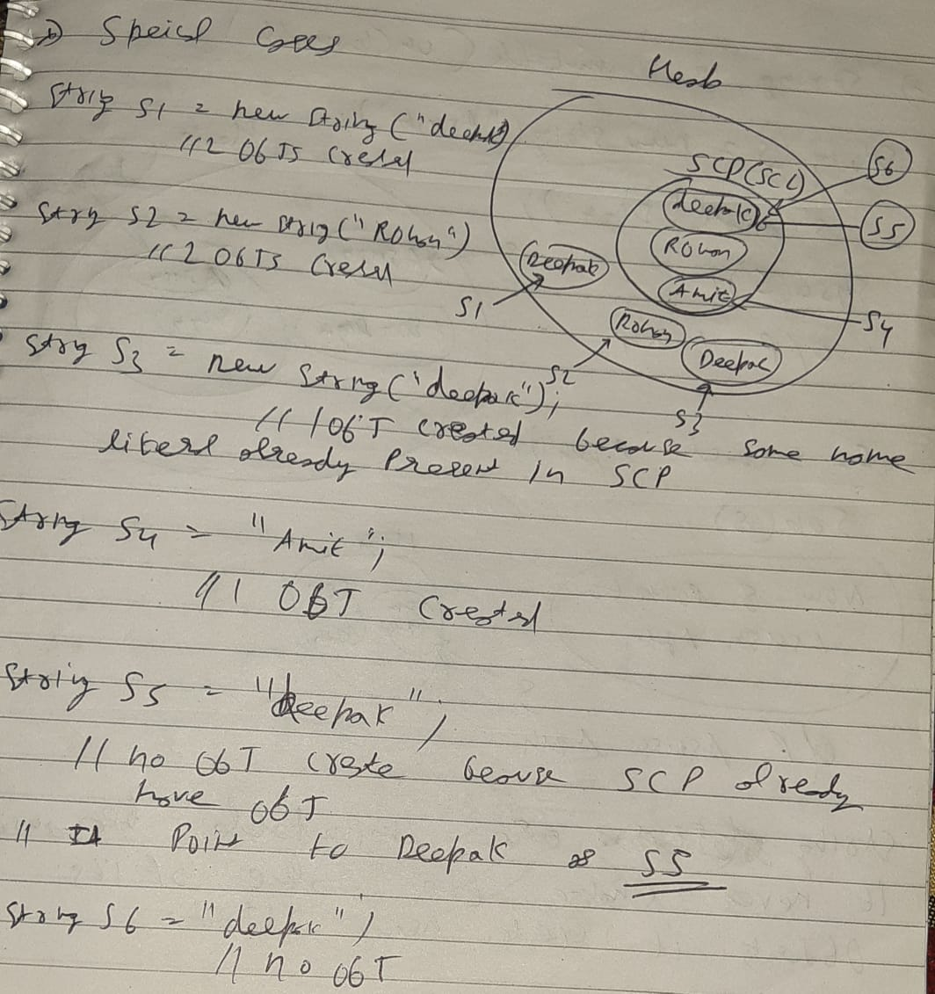

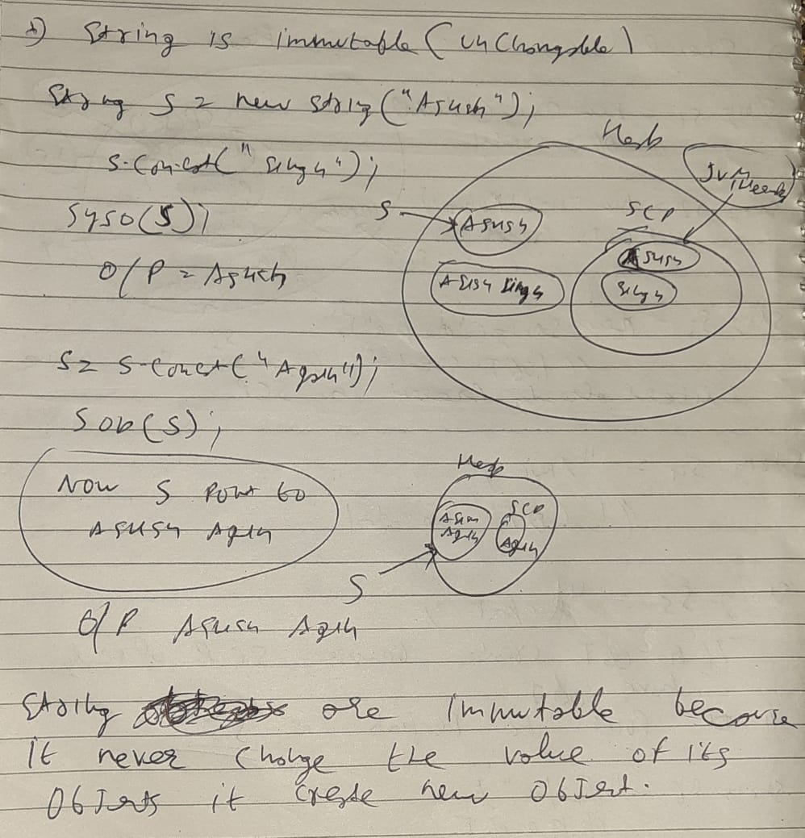

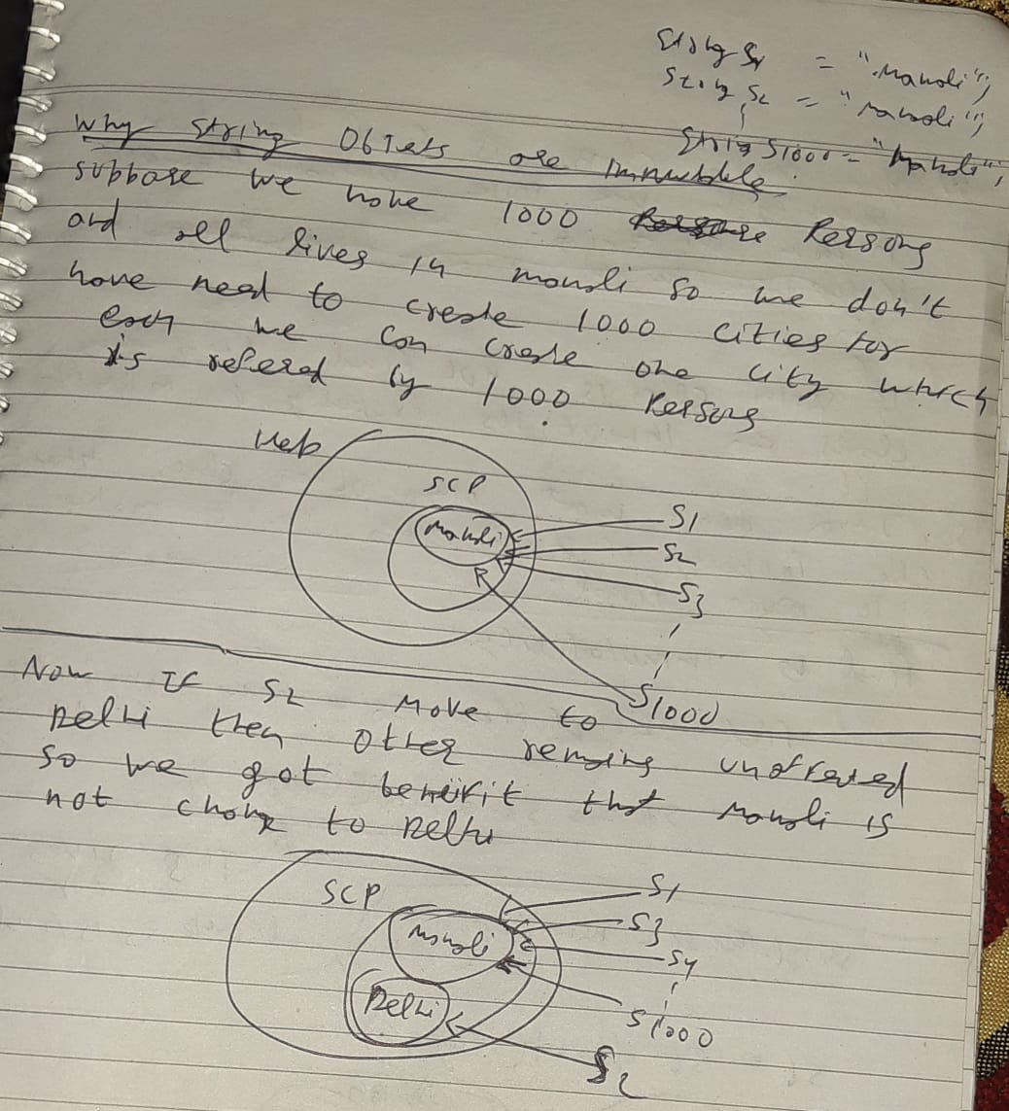

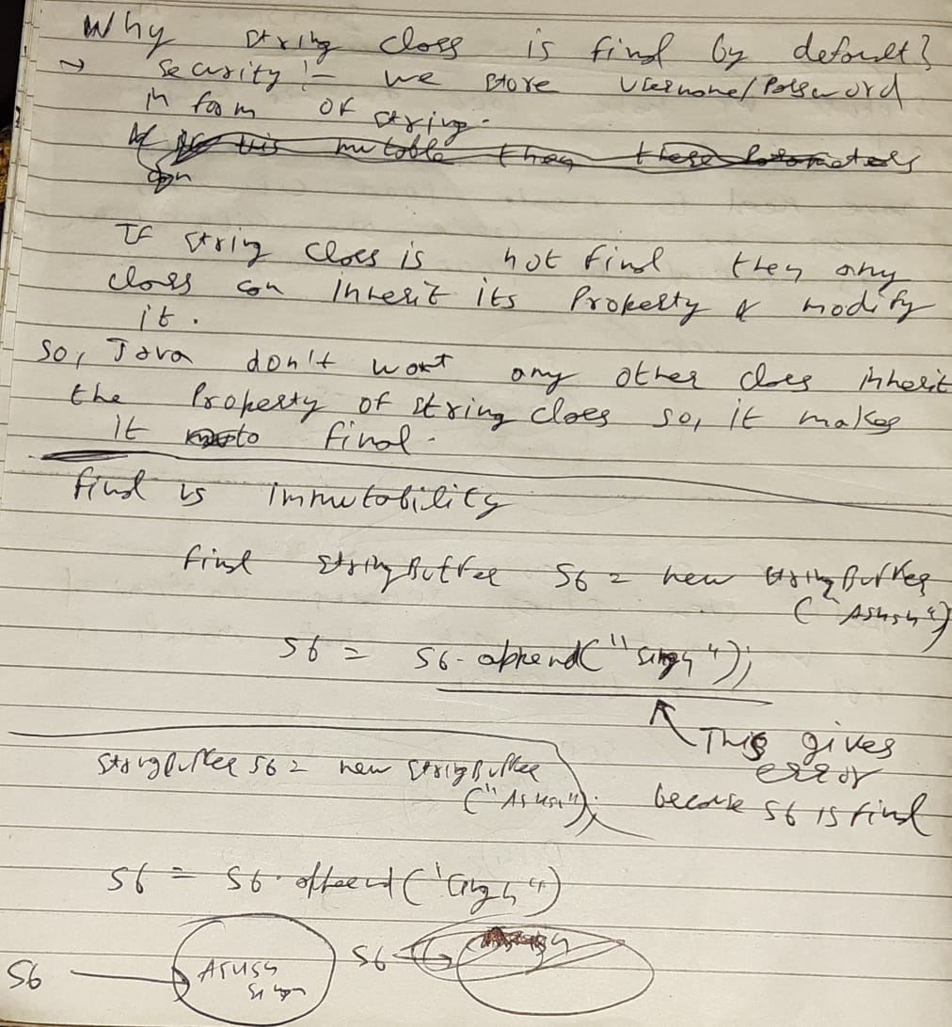

**Arrays :**

an array is a collection of similar type of elements

Array in Java is index-based, the first element of the array is stored at the 0th index, 2nd element is stored on 1st index and so on.

### Advantages

* **Code Optimization:** It makes the code optimized, we can retrieve or sort the data efficiently.
* **Random access:** We can get any data located at an index position.

### Disadvantages

* **Size Limit:** We can store only the fixed size of elements in the array. It doesn't grow its size at runtime. To solve this problem, collection framework is used in Java which grows automatically.

### Types of Array in java

There are two types of array.

* Single Dimensional Array: **int** a[]={33,3,4,5};//declaration, instantiation and initialization
* Multidimensional Array:

**int** arr[][]={{1,2,3},{2,4,5},{4,4,5}};

1 2 3

2 4 5

4 4 5

**Practice coding questions on array**

**Packages in java:**

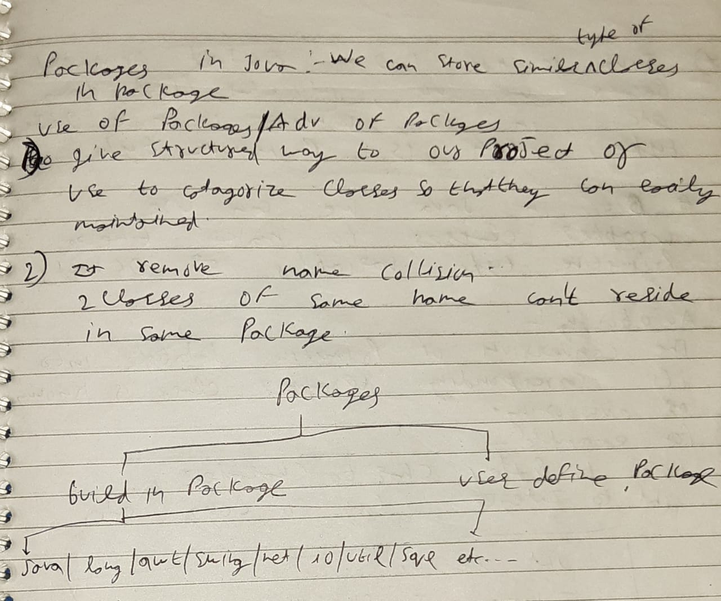

How to access package from another package?

There are three ways to access the package from outside the package.

1. import package.*;
2. import package.classname;
3. fully qualified name.

**package** test2;

**public** **class** B {

**public** **void** disp() {

System.***out***.println("in calss B");

}

}

**package** test1;

**import** test2.*; //Using packagename.*

**import** test2.B; //Using packagename.classname

**public** **class** A {

**public** **static** **void** main(String[] args) {

B ob = **new** B();

ob.disp();

test2.B ob2 = **new** test2.B(); //Using fully qualified name

ob2.disp();

}

}

# Wrapper classes in Java

Java is not 100% object oriented because it use primitive datatypes like int,char,short,long etc..

The **wrapper class in Java** provides the mechanism to convert primitive into object and object into primitive.

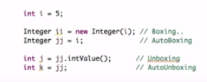

## Autoboxing

The automatic conversion of **primitive data type into its corresponding wrapper class** is known as autoboxing, for example, byte to Byte, char to Character, int to Integer, long to Long, float to Float, boolean to Boolean, double to Double, and short to Short.

**public** **class** WrapperExample1{

**public** **static** **void** main(String args[]){

//Converting int into Integer

**int** a=20;

Integer j=a;//autoboxing, now compiler will write Integer.valueOf(a) internally

System.out.println(a+" "+i+" "+j);

}}

Output: 20 20

## Unboxing

The automatic **conversion of wrapper type into its corresponding primitive type** is known as unboxing.

**public** **class** WrapperExample2{

**public** **static** **void** main(String args[]){

//Converting Integer to int

Integer a=**new** Integer(3);

**int** j=a;//unboxing, now compiler will write a.intValue() internally

System.out.println(a+" "+j);

}}

Output:

3 3

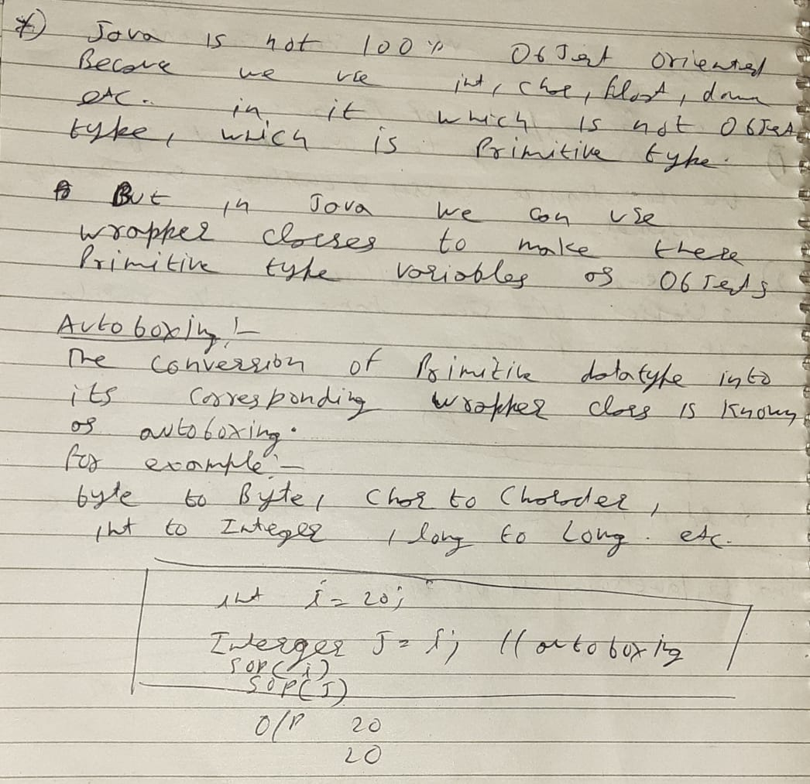

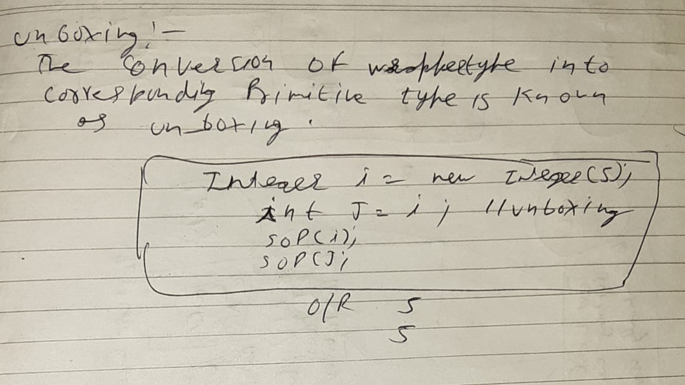

**Where to use wrapperclasses?**

**Wrapper classes used in collection framework**

ArrayList<Integer> list1 = **new** ArrayList<Integer>(); // it can store only integer object

**Collection Framework:** Java collection framework works with objects only. All classes of the collection framework (ArrayList, LinkedList, Vector, HashSet, LinkedHashSet, TreeSet, PriorityQueue, ArrayDeque, etc.) deal with objects only.

**What is file handling in java?**

File handling implies how to read from and write to file in java.

Java.io package allow to do all input and output tasks in java.

**Read and Write in a excel file:**

**Why we want to write in a excel file?**

To print the status weather our scenario[for ex: login] is successful or not

package ReadExcelData;

import java.io.*;

import java.util.concurrent.TimeUnit;

import org.apache.poi.xssf.usermodel.XSSFSheet;

import org.apache.poi.xssf.usermodel.XSSFWorkbook;

import org.openqa.selenium.By;

import org.openqa.selenium.WebDriver;

import org.openqa.selenium.WebElement;

import org.openqa.selenium.chrome.ChromeDriver;

import io.github.bonigarcia.wdm.WebDriverManager;

public class ReadExcel1 {

public static WebDriver driver;

public static void main(String[] args) throws Exception {

WebDriverManager.chromedriver().setup();

driver = new ChromeDriver();

driver.manage().timeouts().implicitlyWait(20, TimeUnit.SECONDS);

File src = new File("./src/main/java/ExcelLocation/excelselenium.xlsx");

FileInputStream fis = new FileInputStream(src);

XSSFWorkbook wb = new XSSFWorkbook(fis); // load full workbook

XSSFSheet sheet1 = wb.getSheetAt(0); // 0 represents "sheet1"

int rowcount = sheet1.getLastRowNum();

System.out.println("total rows is : " + rowcount);

for (int i = 1; i <= rowcount; i++) {

String colonevals = sheet1.getRow(i).getCell(0).getStringCellValue();

String coltwovals = sheet1.getRow(i).getCell(1).getStringCellValue();

System.out.println(colonevals);

System.out.println(coltwovals);

driver.get("http://demo.t3-framework.org/joomla30/index.php/en/joomla-pages/sample-page-2/login-page");

WebElement uname = driver.findElement(By.id("username"));

uname.clear();

uname.sendKeys(colonevals);

WebElement pswd = driver.findElement(By.id("password"));

pswd.clear();

pswd.sendKeys(coltwovals);

WebElement login = driver.findElement(By.xpath("//button[@type='submit']"));

login.click();

// driver.navigate().refresh();

WebElement menu_example = driver.findElement(By.xpath("//span[text()='Menu Example']"));

String textcomp = menu_example.getText();

if (textcomp.contains("ample")) {

sheet1.getRow(i).createCell(2).setCellValue("PASS");

FileOutputStream fos = new FileOutputStream(src);

wb.write(fos);

} else {

sheet1.getRow(i).createCell(2).setCellValue("Fail");

FileOutputStream fos = new FileOutputStream(src);

wb.write(fos);

}

}

wb.close();

}

}

**Can main method override/overloaded?**

We can overload but cant override

**package** QA;

**public** **class** callbyvalue {

**public** **static** **void** main(Object[] args) {

System.***out***.println("asaswweeeeee");

}

**public** **static** **void** main(String[] args) {

System.***out***.println("asasas");

}

}

**Wait vs Sleep method in java?**

**Define syso?**